** First uninstall all Sql server versions and visual studio previously installed. Then use CCleaner to clear all temporary files and use the built in registry cleaner to clean the registry. Delete all SQL Server Files from Program Files.

Step 1. If the following screen does not show up automatically after inserting the SQL SERVER DVD in the DVD drive, explore the DVD and click on “setup.exe”. The DVD is available with Sandeep Dey.

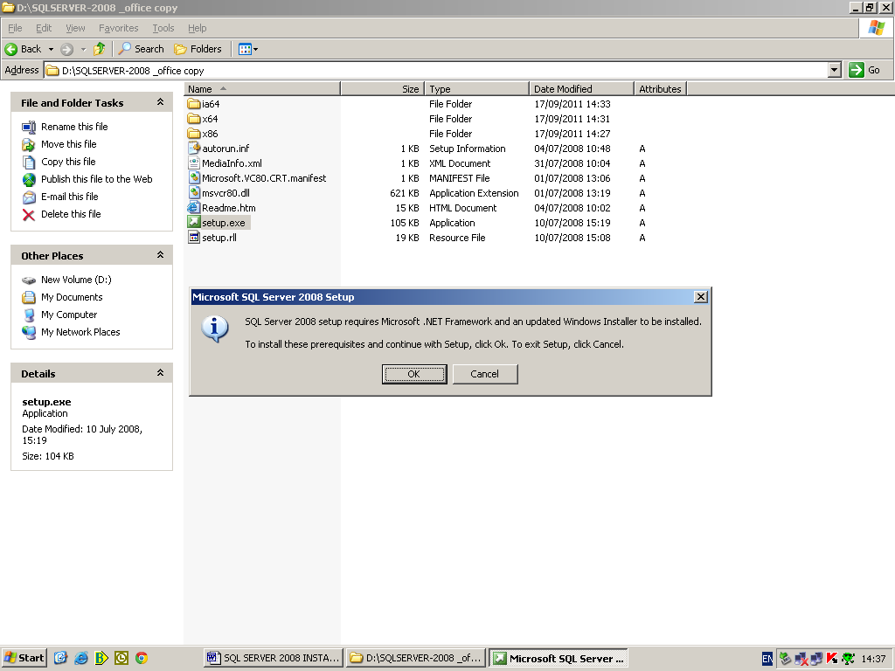

Step 2. Click “OK”.

Step 3. Click “Next”.

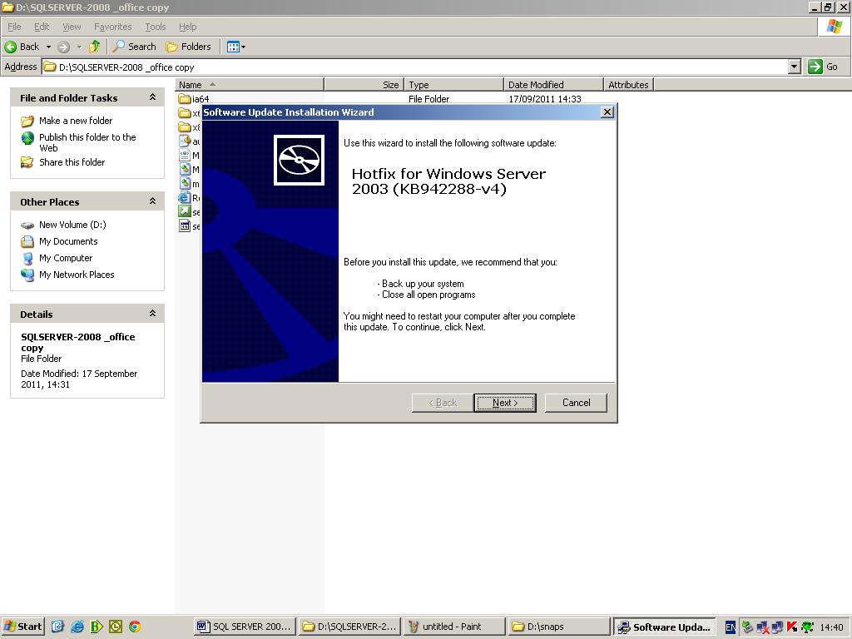

Step 4. Select “I Agree” and then click “Next”.

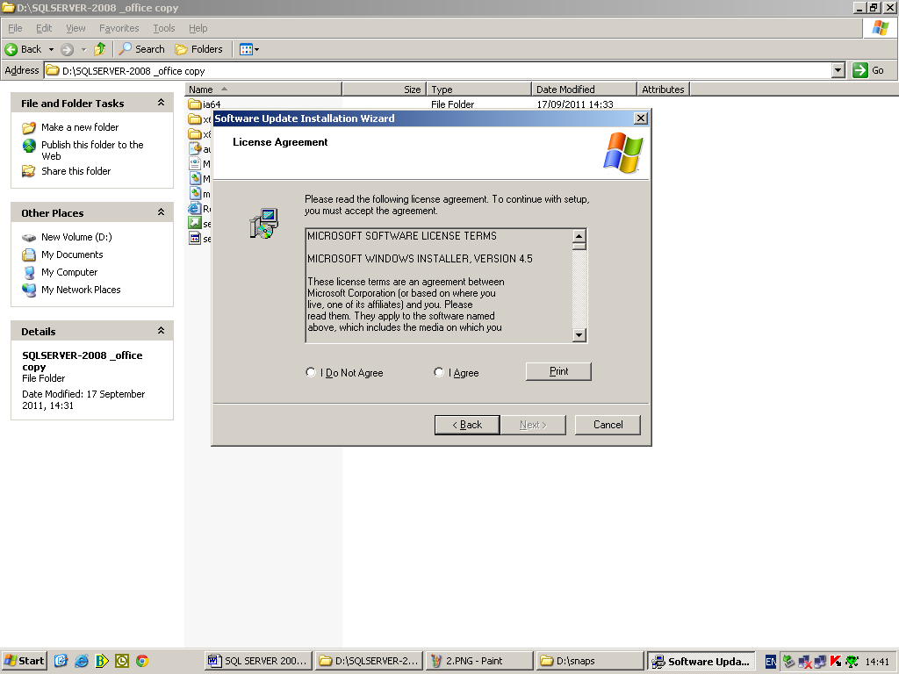

Wait for the setup to update your system.

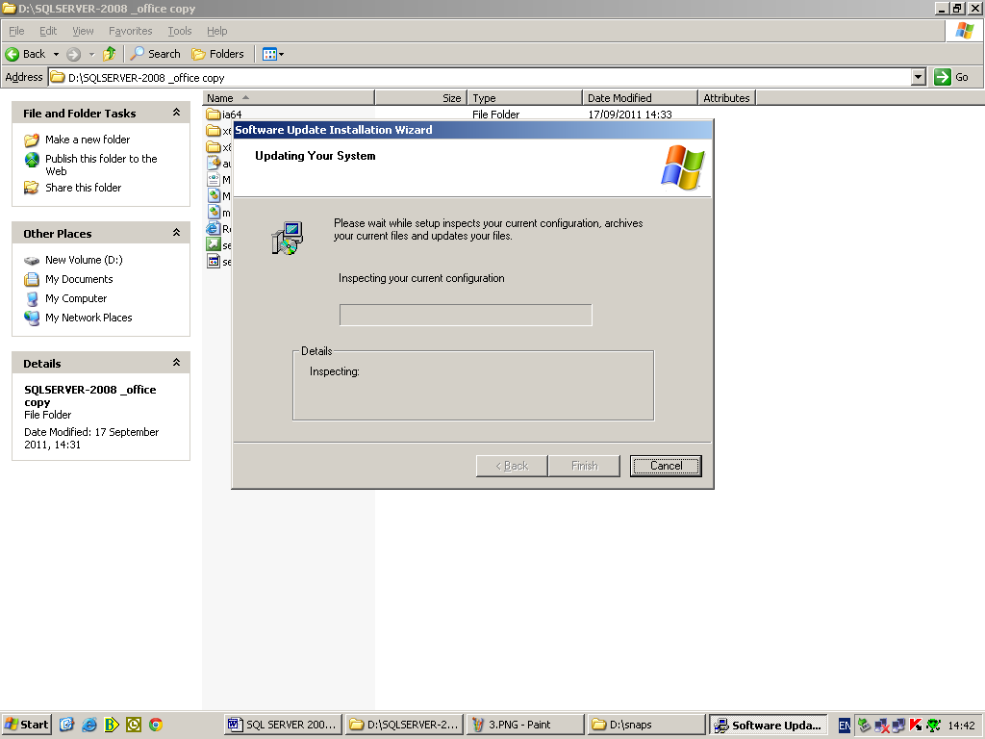

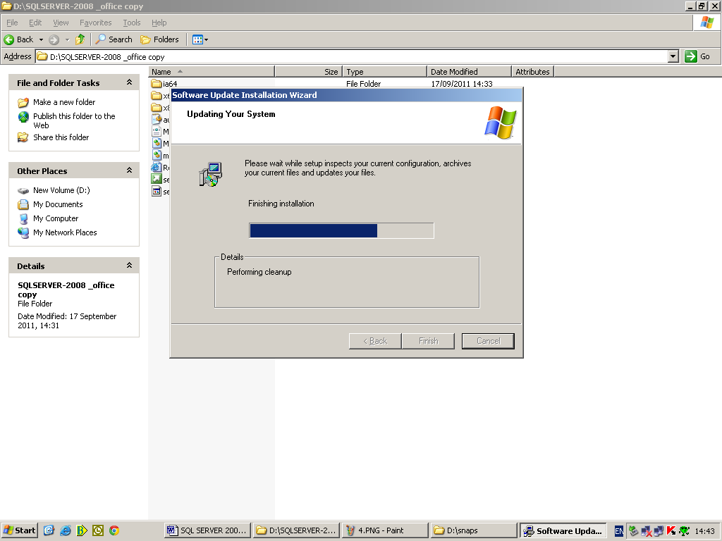

Step 5. Click “Finish”.

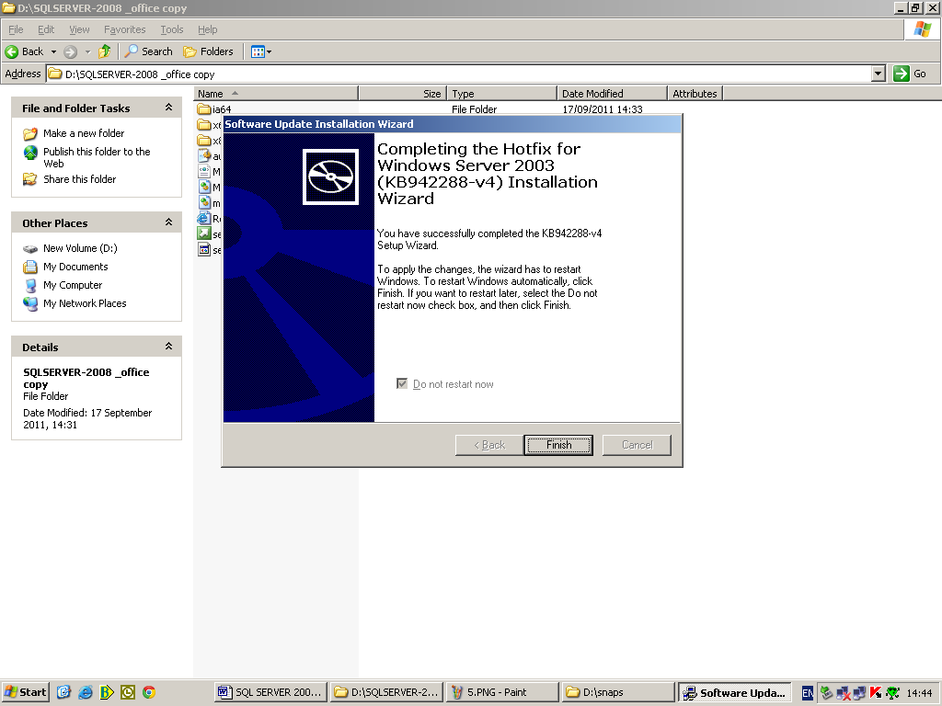

Step 6. Click “OK” and restart the computer.

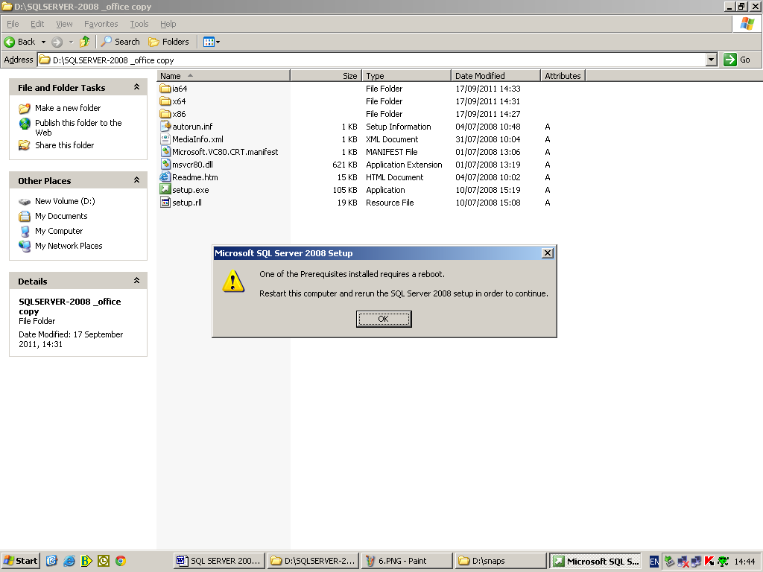

Screenshot after restart. Wait while SQL Server 2008 Setup processes the current operation.

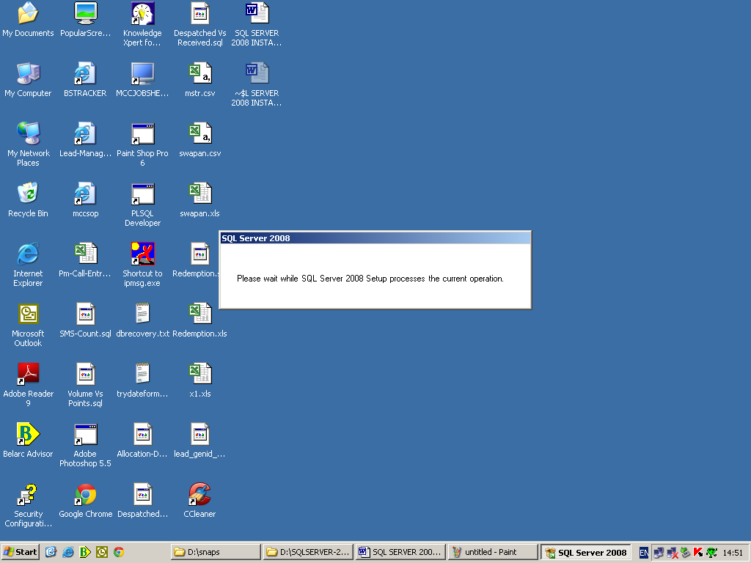

Step 7. Click on “Installation” and then click the first option from the list under installation i.e. “New SQL Server Standalone Installation or to add features to an existing SQL Server 2008 instance”.

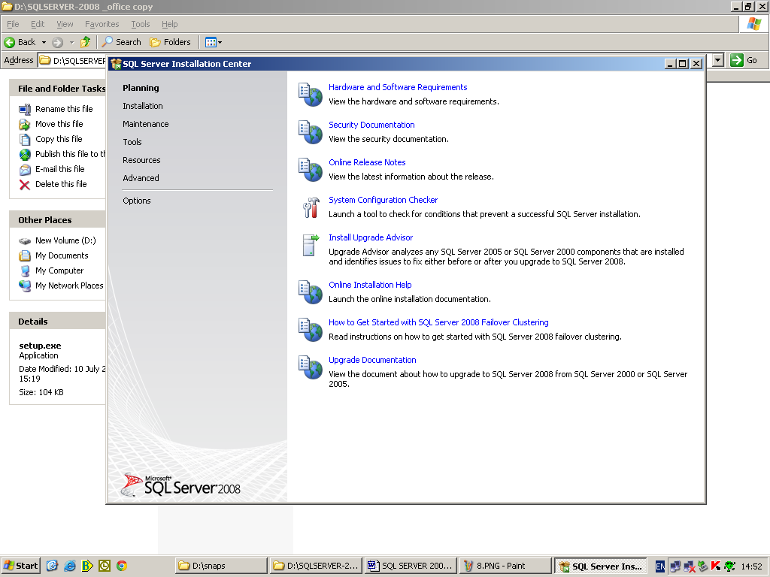

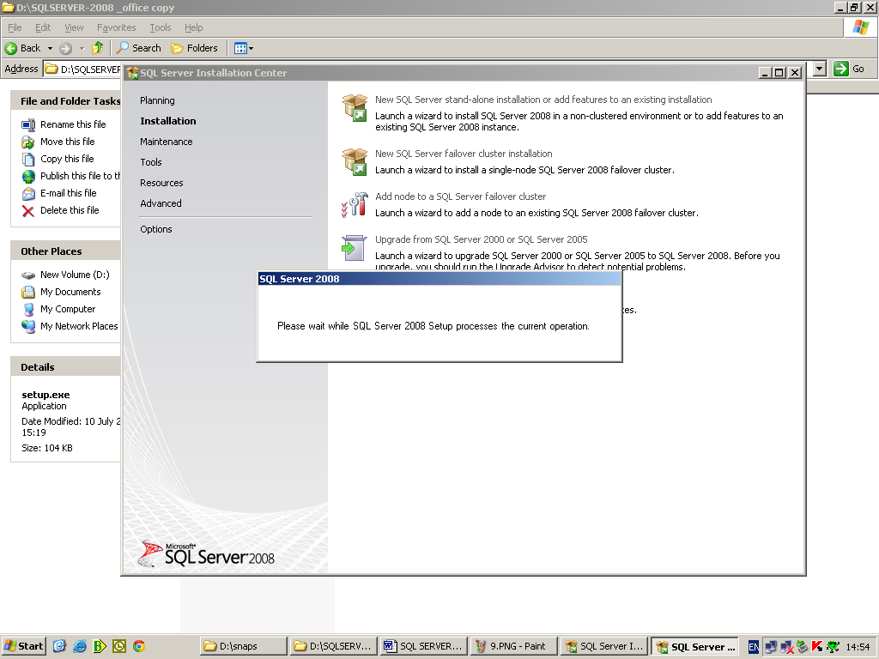

Step 8. Click “OK”.

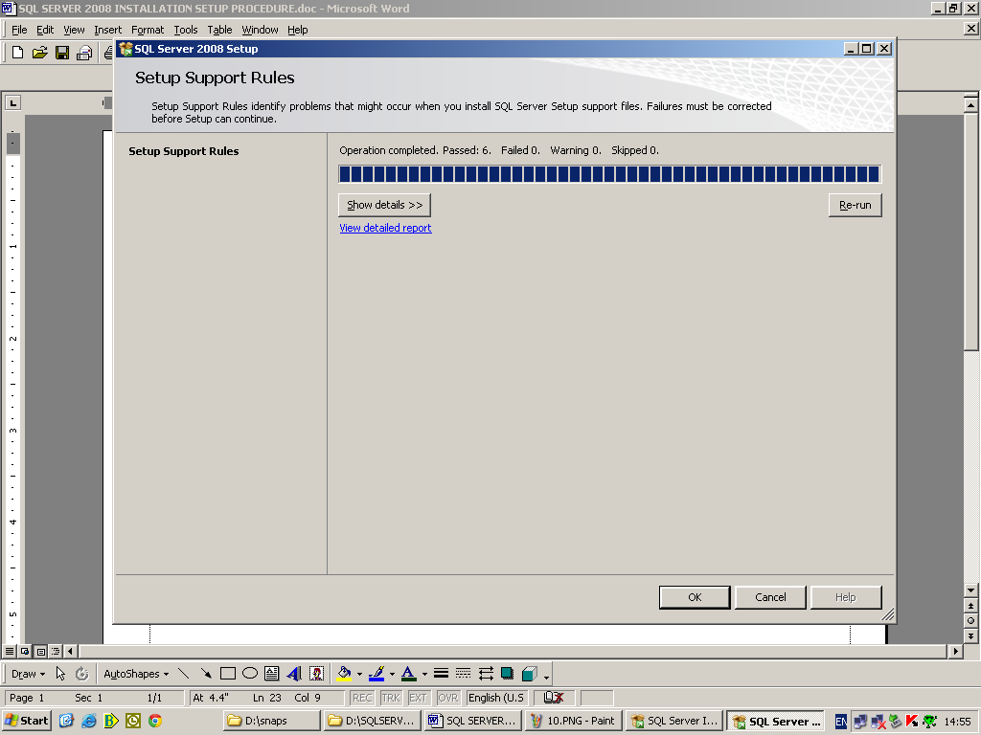

Step 9. Select “Enter the product key” and enter the mentioned product key as shown. Click “Next”.

Product Key: M4GVW-J4BMK-6JMKJ-PG7KV-R842G

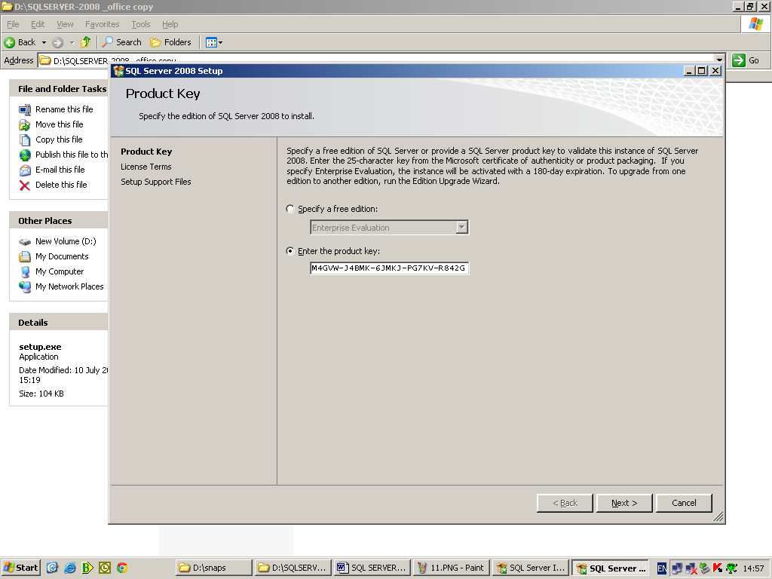

Step 10. Select “I accept the license terms” and then click “Next”.

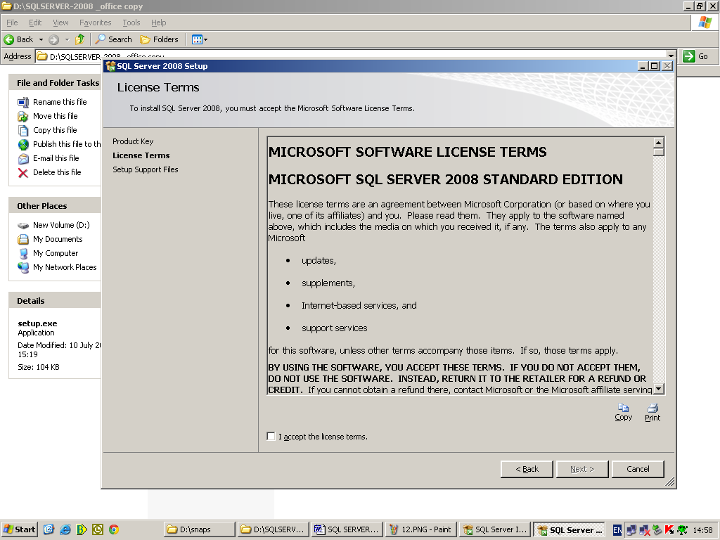

Step 11. Click “Install”.

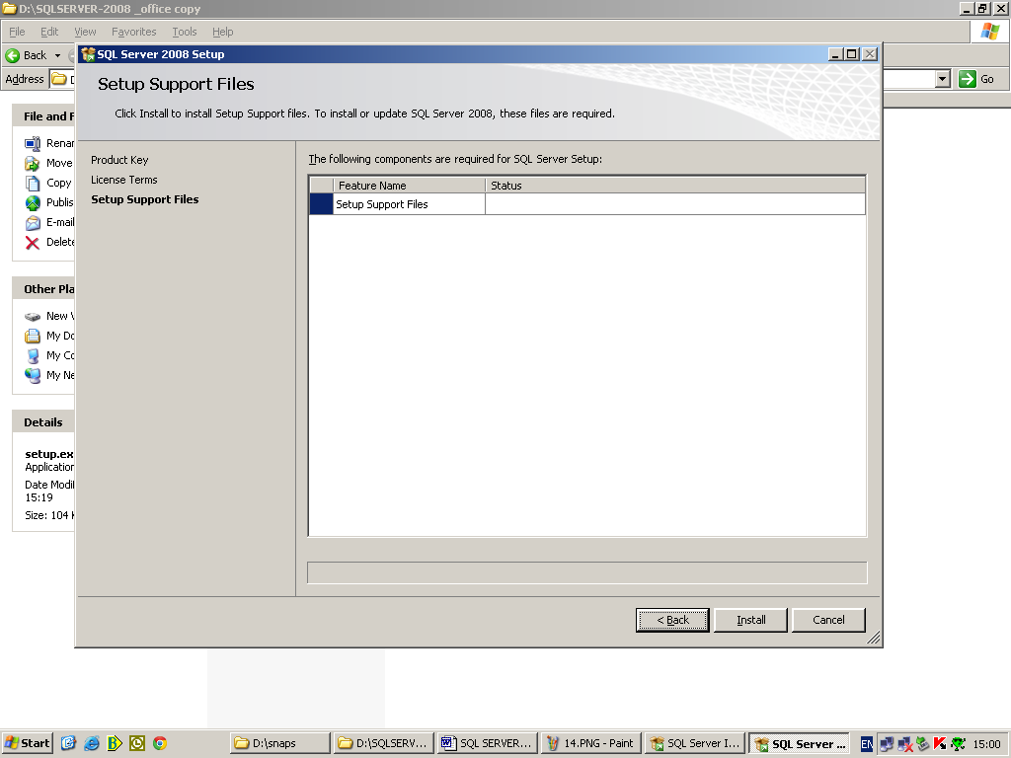

Wait for the “Setup Support Files” installation to complete.

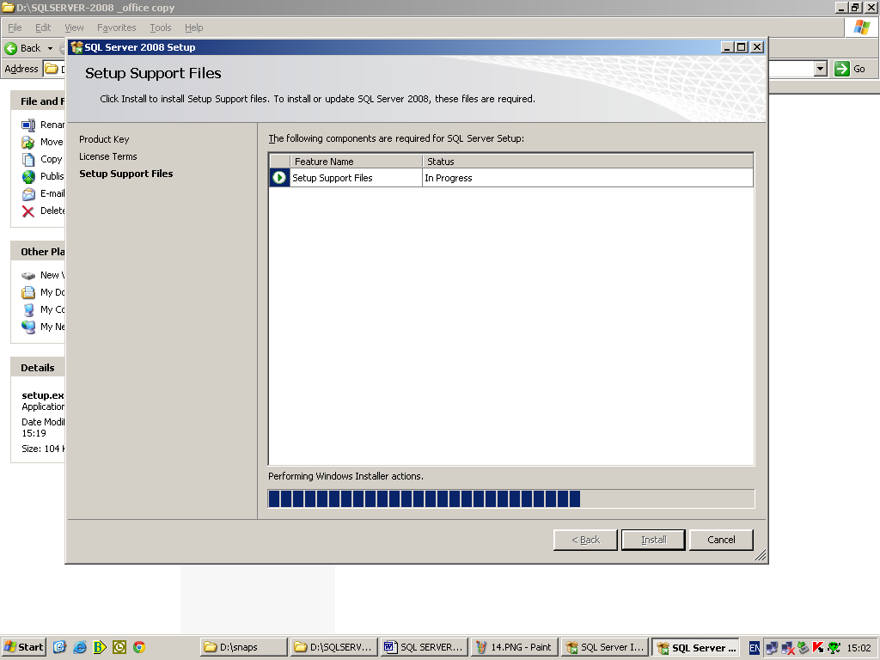

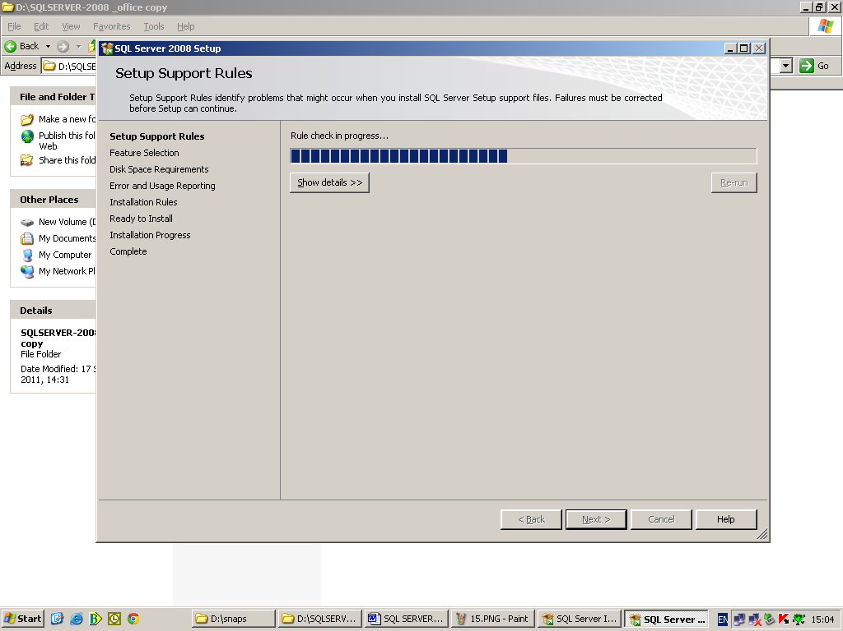

Step 12. Click “Next”.

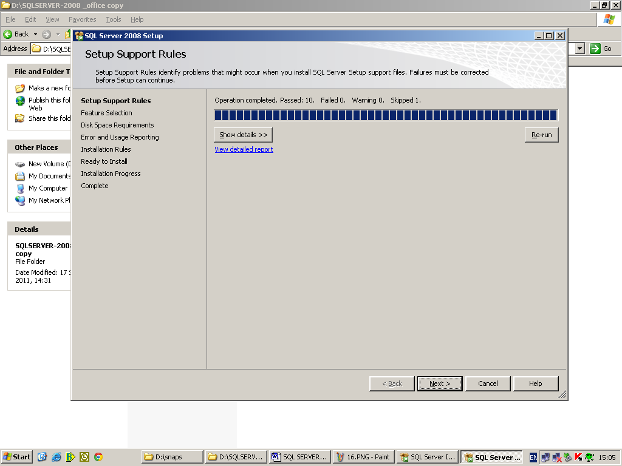

Step 13. Click “Select All” and then click Next.

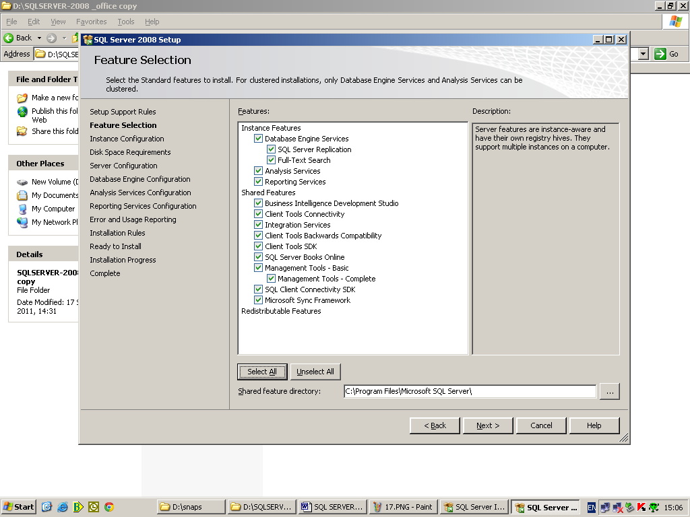

Step 14. Click “Next”.

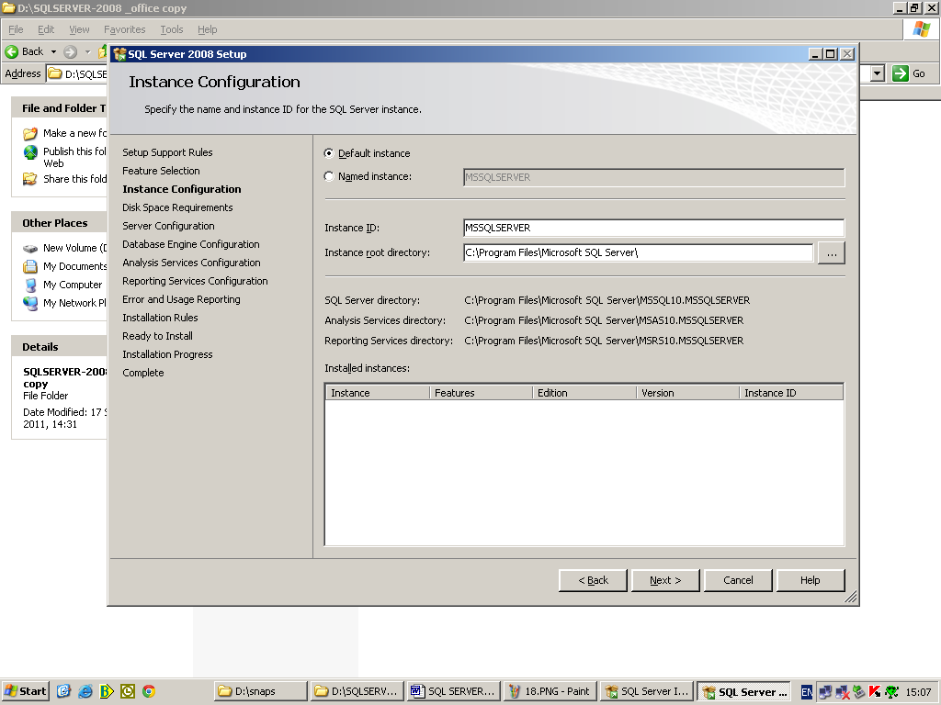

Step 15. Click “Next”.

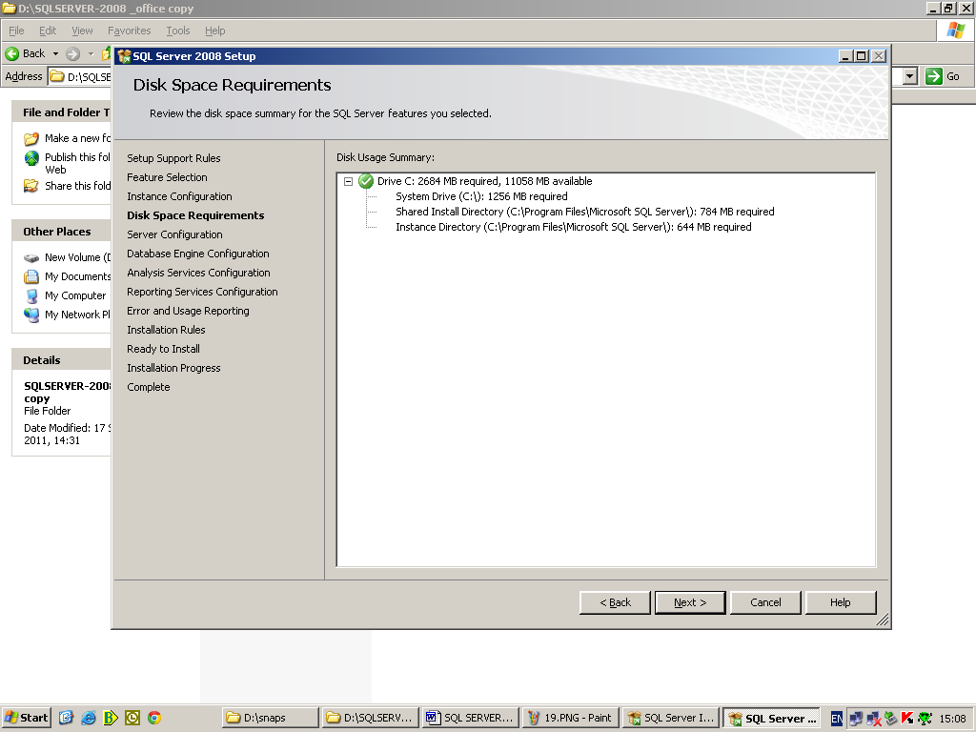

Step 16. Select Account Name as “NT AUTHORITY\SYSTEM” and Startup Type as “Automatic” for all Sql Server Services*. Click Next.

*Note: Leave Account Name and Password for “SQL Full-text Filter Daemon Launcher” service as it is.

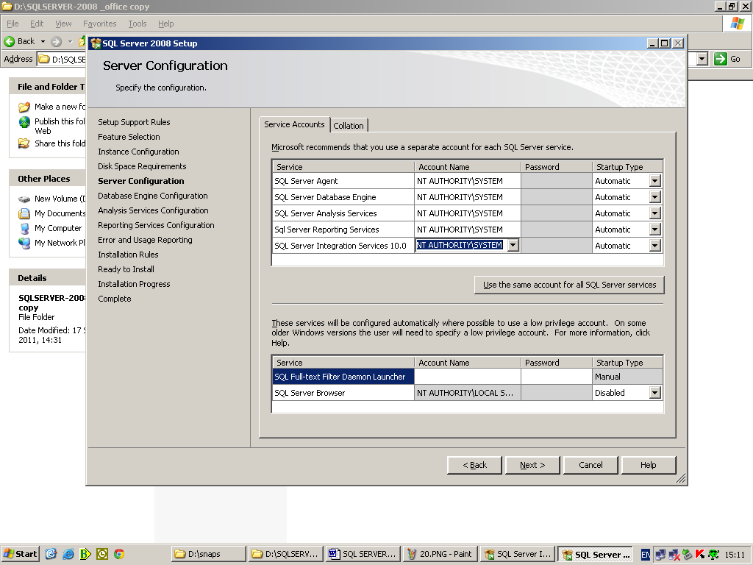

Step 17. Select “Mixed Mode” and give password as “ram1653$”. Click “Add Current User”. Click “Next”.

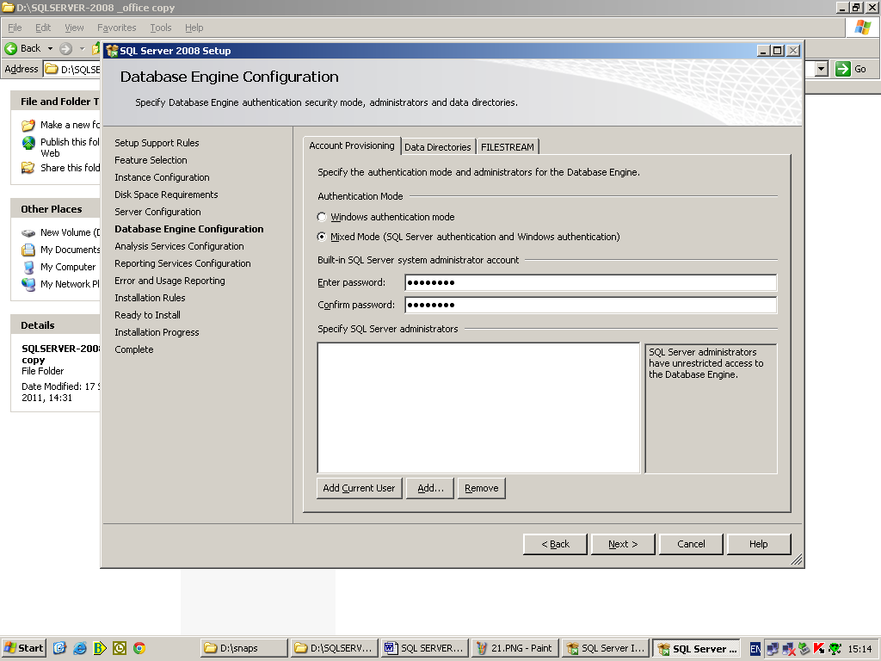

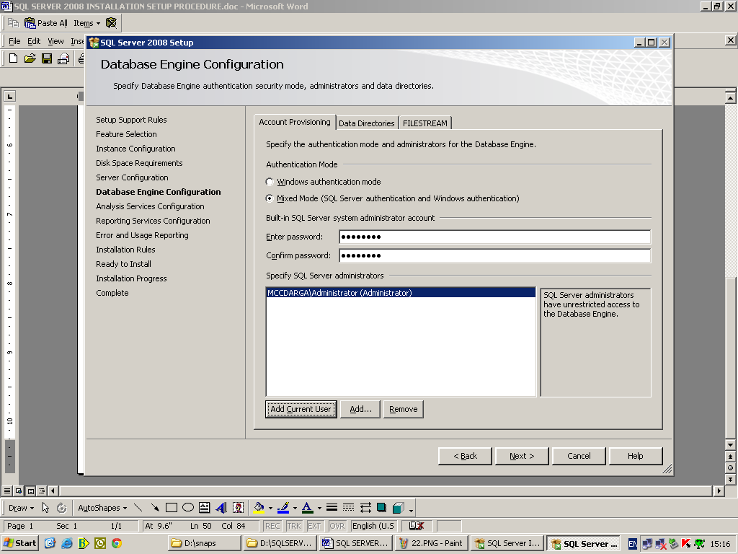

Step 18. Click “Add Current User”. Click “Next”.

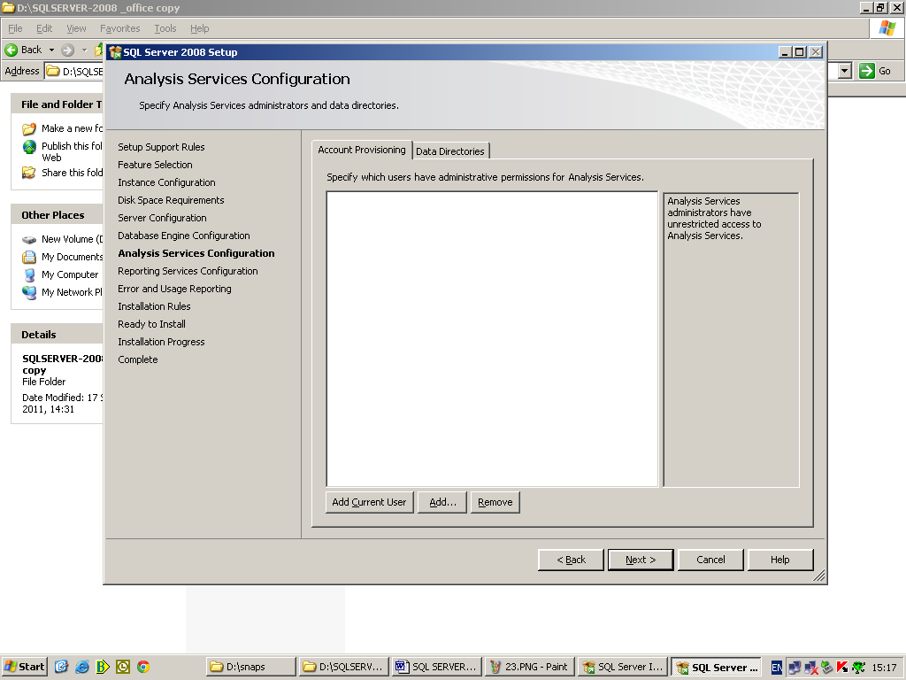

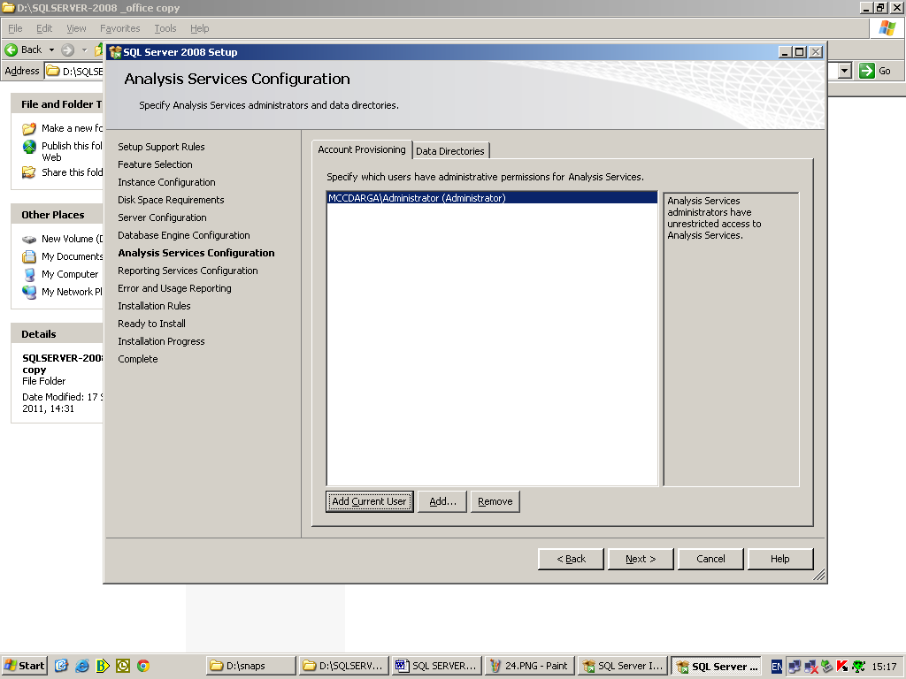

Step 19. Click “Next”.

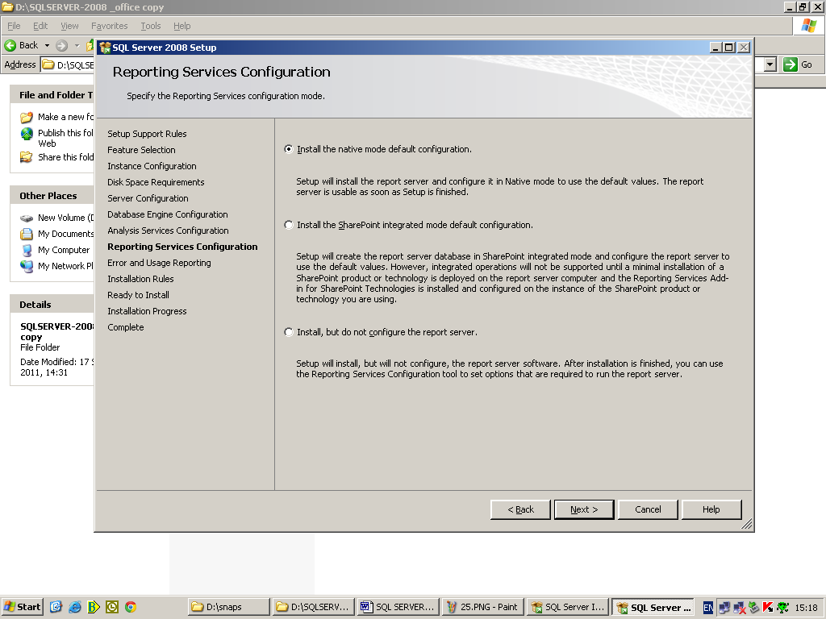

Step 20. Click “Next”.

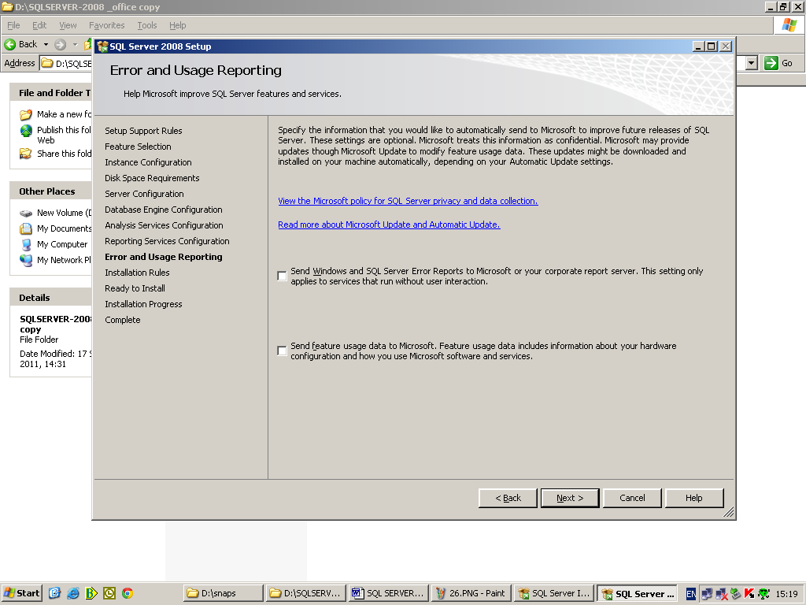

Step 21. Click “Next”.

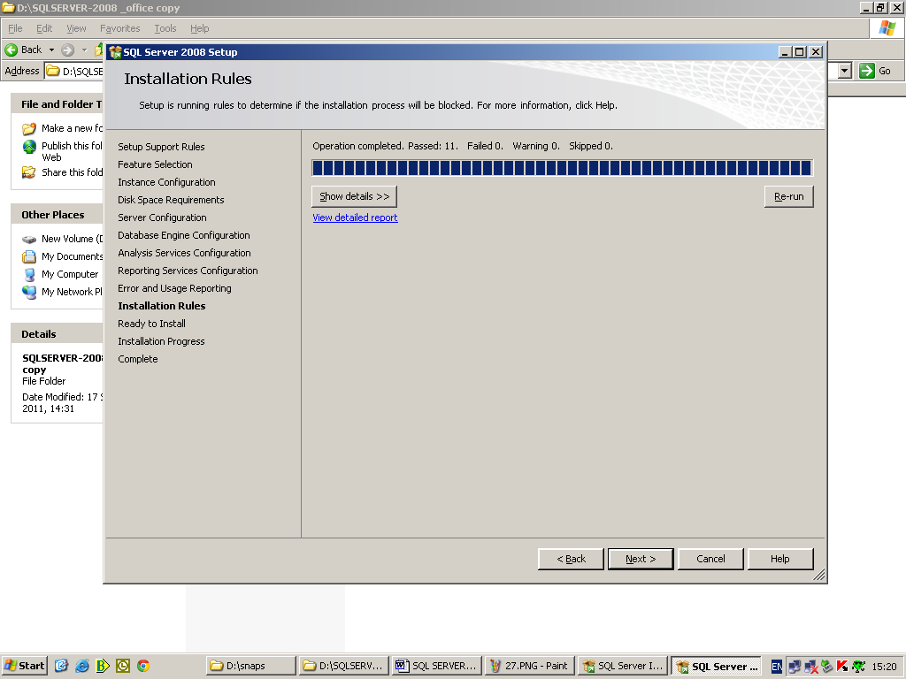

Step 22. Click “Install”.

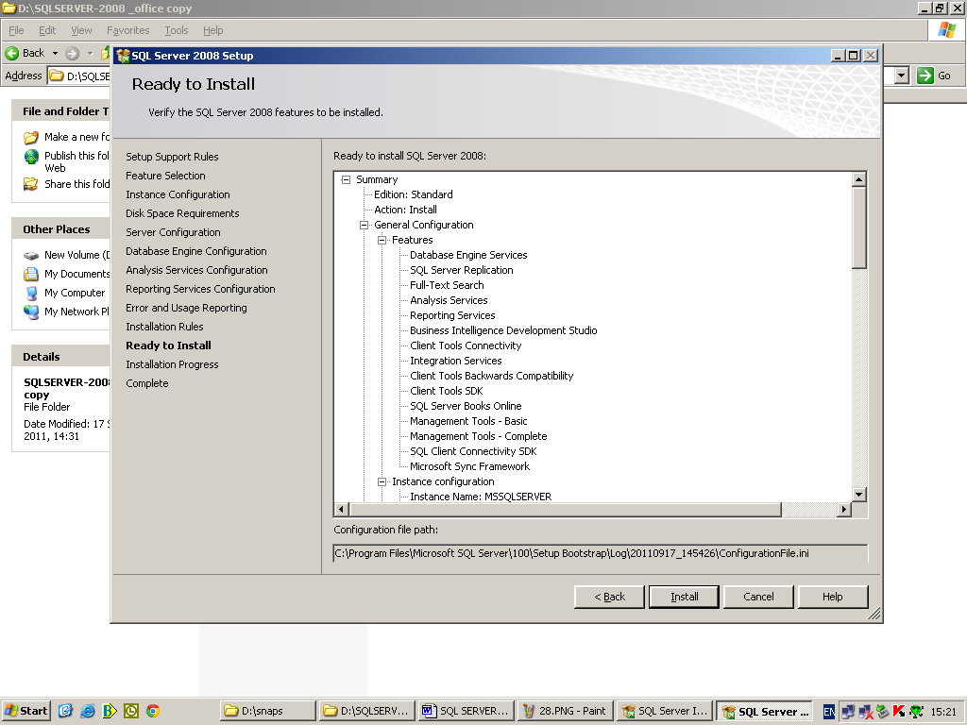

Wait for the installation to complete.

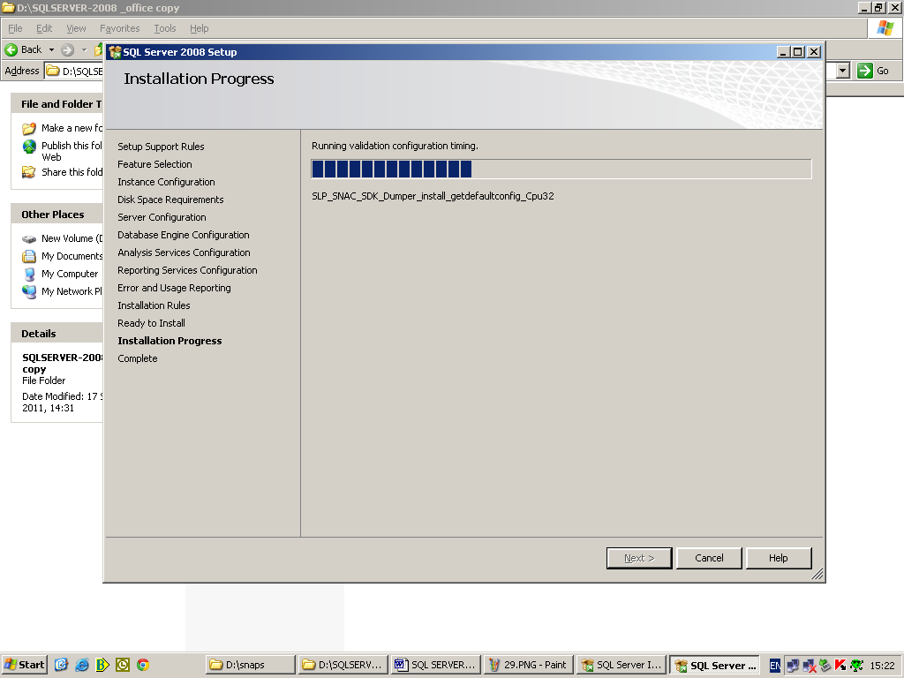

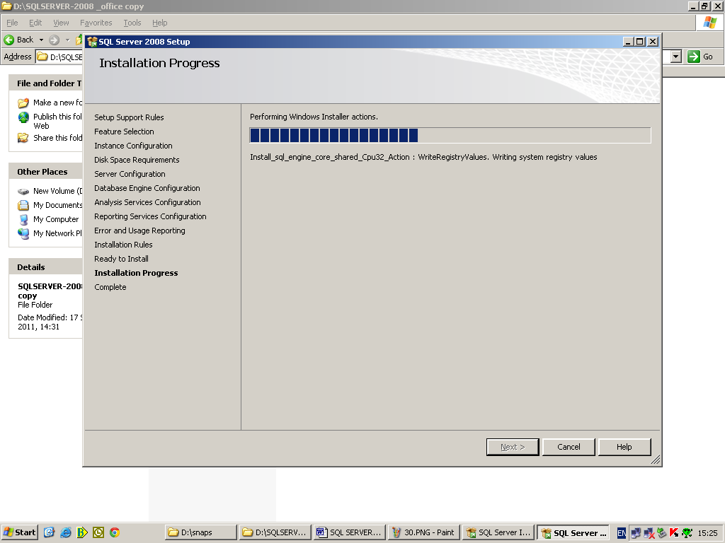

Step 23. Click “OK”.

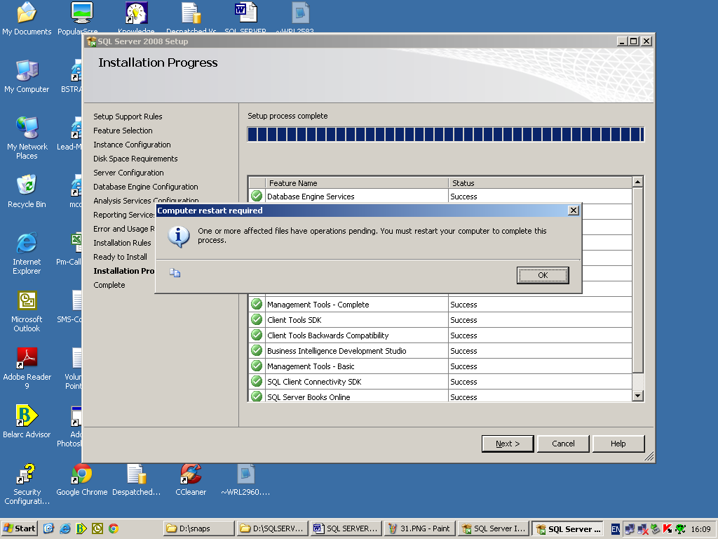

Step 24. Click “Next”.

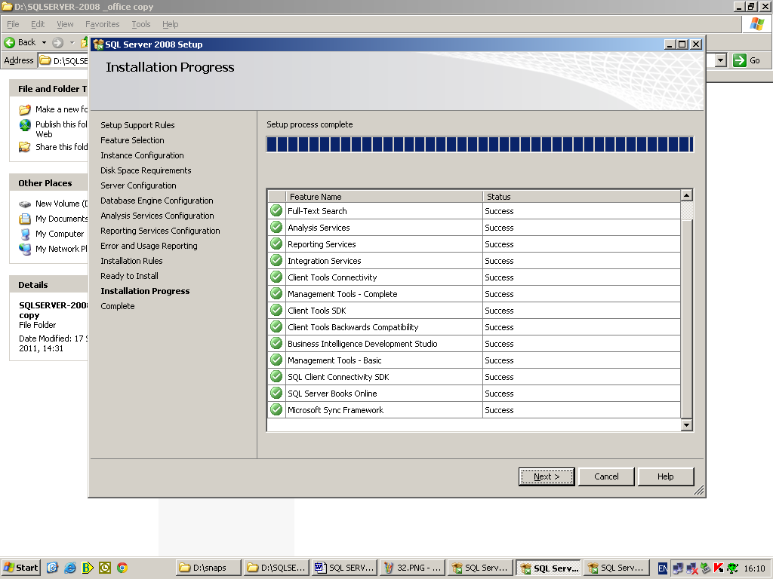

Step 25. Click “Close”.

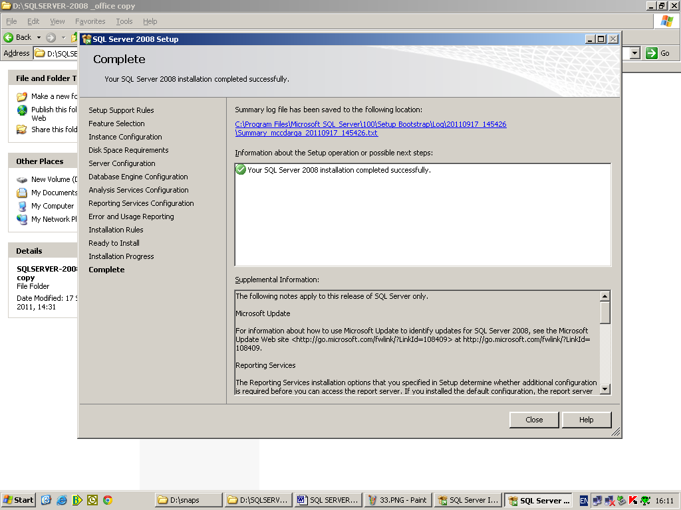

Step 26. Click “OK”.

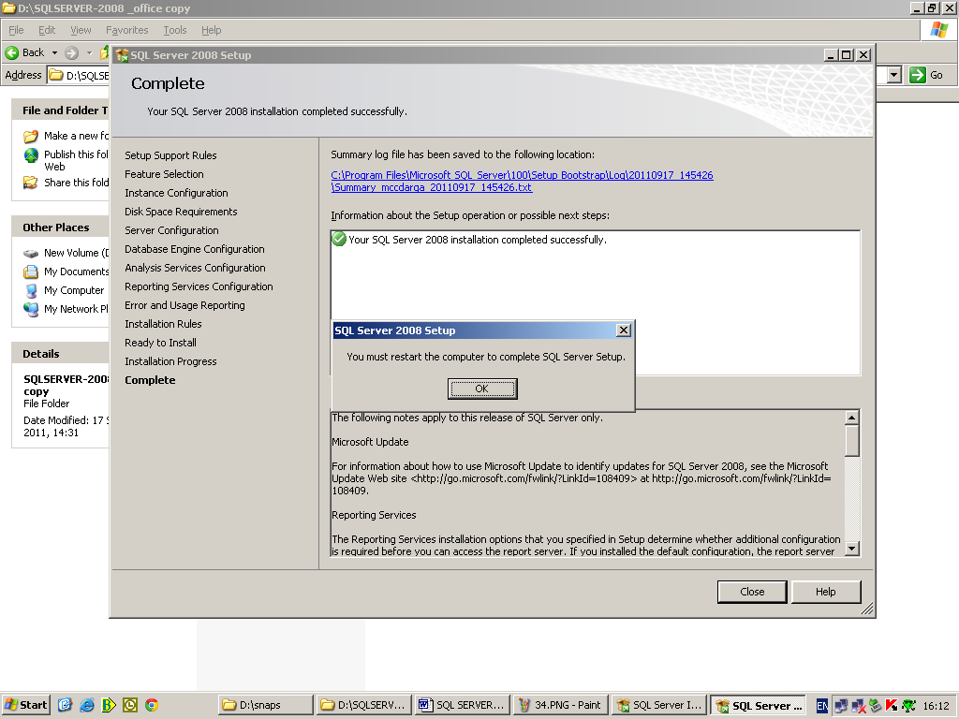

Step 27. Restart the computer and enjoy☺.

